**Rag Outs**-

These are linen items that are worn out or damaged beyond repair. In 2022, we recycled 339,306 pounds of rag outs. These items are bailed and go to a rag vendor, *Buffalo Industries*. Since 1929, *Buffalo Industries* has been taking white & colored linen products and producing quality recycled new **rags and wipers.**

**Recycled White Cloth Rags**

* + Recycled White T-Shirts
  + Recycled Industrial  
    White T-Shirts
  + Recycled White T-Shirts  
    with Colored Trim
  + Recycled White Sweatshirts
  + Recycled White Turkish Toweling

**New White Cloth Rags**

* + New Rag Roll
  + New Ultimate Fine Finish Wipers
  + New Bleached Knits

**Recycled Colored Cloth Rags**

* + Recycled Colored T-Shirts
  + Recycled Colored Sweatshirts
  + Recycled Colored Flannel
  + Recycled Colored  
    Turkish Toweling

**Cloth Rag Benefits**

* More durable than paper
* Cut in usable-sized pieces
* Washable & economical

**Ideal Uses**

* General cleaning
* Paint spills & cleanup
* Staining & varnishing
* 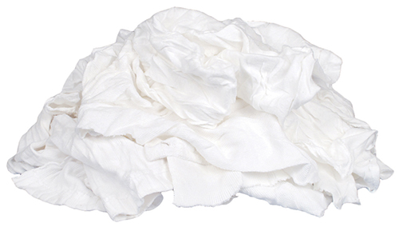Polishing & dusting

**Plastic-**

*Green Planet 21* is our plastic vendor and recycles soiled linen bags and other plastic bags and wrappings received at the laundry. We recycled 271,220 pounds of plastic in 2022. These items are bailed and taken by *Green Planet 21*. Where they are remade into products too numerous to list.

They offer plastics recycling services for a variety of grades of materials, including films, HDPE or LDPE, shrink wrap, and polycarbonate.

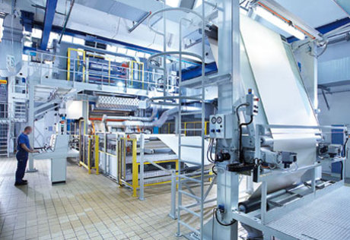Plastics recycling is hugely beneficial for the environment. Producing products from recycled plastic requires significantly less energy than manufacturing plastic from scratch, thereby savings carbon and other GHG emissions. Manufacturing virgin plastics requires a large amount of water, petroleum, natural gas and coal as raw material. Some estimate that around 40% of petroleum consumption can be reduced by simply recycling discarded and old plastic waste.

**Cardboard**

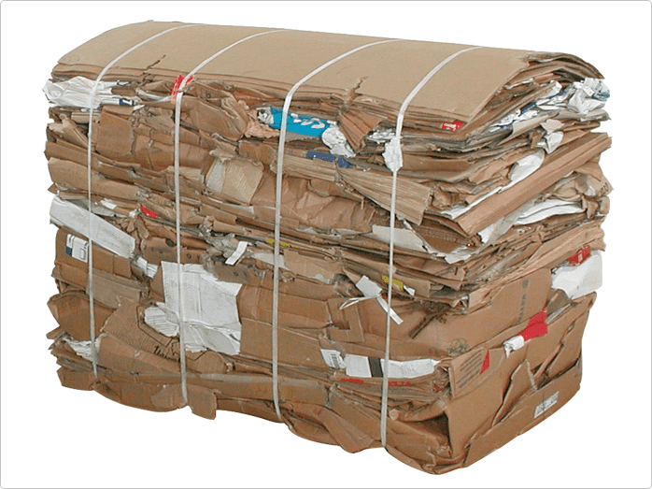Cardboard is baled and picked up by *Evergreen Recycling* in Seattle. In 2022, we recycled 49,850 pounds of cardboard.

* Recycling one ton of cardboard saves 682.5 gallons of oil, 7,000 gallons of water, or 3.3 cubic yards of landfill space.
* Every ton of recycled cardboard saves about 17 trees.
* Recycled cardboard requires 64% less energy than making cardboard from virgin wood pulp.

**Pallets**

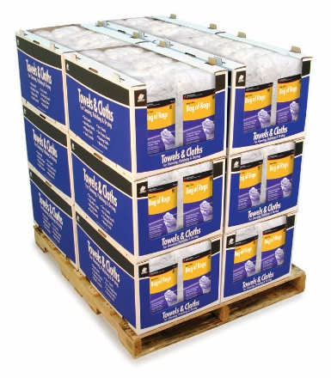In 2022, we recycled 42,883 pounds of pallets. *Buffalo Industries* also recycles our pallets for us and repurposes them for use with their rag products. They offer the following pallets for the industry.

# **Pallet Displays**

Open front, interlocking pallet display boxes. Ideal for off-shelf, promotional sales.

#### Pallets Offered:

* **Half Pallets** (6 boxes) - 42″ wide x 50″ high x 24″ deep
* **Full Pallets** (12 boxes) - 42″ wide x 50″ high x 48″ deep
* **Split Pallets** (full or half). 20″ wide x 17″ high x 23.75″ deep

**Water**

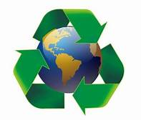HCSA recycles water at approximately 57%, in 2022 we recycled 23,631,555 gallons of water with an in-house recycling process.